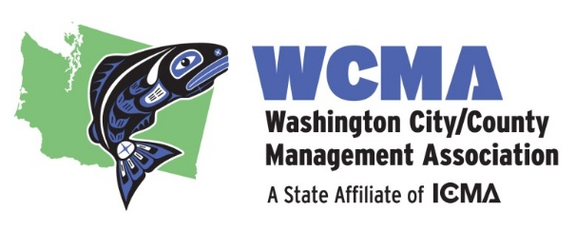

Graduate School Scholarship Opportunity
Washington City/County Management Association (WCMA)
Application Materials

"I am honored to be associated with Washington’s city/county managers. Receiving this award has meant a tremendous amount to me. It is an investment in me as a future leader, and will indelibly shape my prospective career path as a public servant. The scholarship has also eased the financial burden of my graduate education, something I am particularly grateful for given the budgetary concerns facing millions of people and thousands of cities nationwide. I am eager to use the scholarship to build community and learn from some of our state’s sharpest government minds. After I graduate, I hope to promote data-driven decision-making to improve community outcomes. I will forever be an advocate of WCMA and look forward to supporting the association in any way I can. Thank you again for this incredible generous award."
– Griffin Lerner, AICP - 2020/2021 WCMA Scholarship Winner

THE WASHINGTON CITY/COUNTY MANAGEMENT ASSOCIATION SCHOLARSHIP
The 2023-2024 WCMA Scholarship is a $5,000 educational fellowship for the 2023-2024Academic Year.

The recipient of this scholarship will be awarded $5,000 to be used for his or her school related expenses. In addition, the recipient will be awarded:

- Complimentary WCMA student membership for 1 year;
- Complimentary registration and two night’s lodging (not to exceed $500) toward the WCMA Summer Conference;
- Mentoring by an active professional city or county manager.
Note: International City/County Management Association (ICMA) may offer complimentary membership and discounted attendance at their 2023 annual conference.

City and County management practitioners recognize the prestige of the WCMA Scholarship and the honor it carries for the student and the academic institution that he or she represents.

ELIGIBILITY CRITERIA
The primary objective of the WCMA Scholarship is to provide financial assistance to students who have chosen to pursue a graduate degree in public administration and who have a desire to work in city or county management. Applicants must: (1) reside in Washington State, (2) have a bachelor's degree, (3) be enrolled in or accepted for admission to a graduate school; preference given to schools in Washington, Oregon and Idaho; on-line graduate programs are acceptable with Washington State residency requirement, and (4) demonstrate a serious commitment to pursue a career in local government

Preference will be given to graduate students pursuing a degree in public administration, public affairs, or public policy.

WCMA BACKGROUND
WCMA is an affiliate of the International City/County Management Association, an organization devoted to enhancing the proficiency of city managers, county managers, and other municipal administrators. The primary goal of the Washington City/County Management Association is to increase the knowledge, proficiency, quality and professionalism of local government management by providing education, information, and support services to members and their agencies. WCMA encourages the development of professional relationships and facilitates the exchange of ideas and information among members. WCMA also actively assists the Association of Washington Cities in its programming, legislative efforts, and support role to local government.

Members include managers, administrators, and assistants of municipalities, counties, and other similar government agencies. Persons pursuing the profession of city or county administration, and individuals who have made distinct contributions to the advancement of the field of public administration also are welcome and encouraged to join. Over 250 managers and assistants are currently members of WCMA.

For more resources available to you, as the next generation of city and county managers, please visit the WCMA next generation web page.

APPLICATION PROCESS
Interested students must complete the attached form and include the following required items with your application:

- A letter of application, no more than two pages in length, describing why you want to enter the city/county management field, what you hope to gain from your experience in receiving the scholarship, and why you believe you should be considered for this scholarship.
- Two letters of reference, one from a previous or current undergraduate or graduate academic instructor and the other from a previous or current work supervisor.
- One official copy of your undergraduate transcripts
- One official copy of your graduate transcripts (if applicable)
  - An initial unofficial copy of your transcripts is sufficient to meet the deadline but must be followed by an official copy of them.

All information is to be compiled into one PDF and submitted via email to Michael Rizzitiello. Please indicate when submitting if your official transcript will be sent directly from your educational institution.

DEADLINE:
The deadline for submission is, 4:00 pm on Friday, May 26th, 2023. Information submitted will be verified prior to the selection of a recipient. Only complete applications will be considered.

Questions during the application period are welcome and may be directed to Michael Rizzitiello.

A committee of current Washington city and county managers and the past recipient will review the applications. All applicants will be notified of the outcome in late June.

